http://www.nytimes.com/2012/06/24/movies/dieudonne-french-comic-behind-the-anti-semite.html

A French Jester Who Trades in Hate

Dieudonné, French Comic Behind ‘The Anti-Semite’

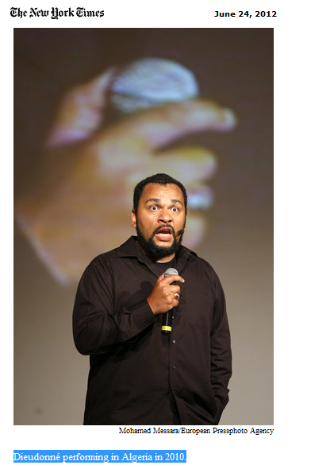THE stand-up comedian and actor Dieudonné used to draw thousands of ecstatic fans to his shows. Famous for his portrayal of an imposing, slightly boorish West African immigrant who spoke an old-fashioned, lilting French while gently mocking a shorter, agitated pal, he has played roles as varied as a nostalgic Vichy-era collaborator, a corrupt garage owner and a gay butcher.
But Dieudonné’s career has gone off the rails. After lashing out at Jews, playing down the importance of the Holocaust in shows and interviews, and becoming politically active in the name of what he calls anti-Zionism, he has become a pariah in France. Today he struggles to sell tickets to his stand-up appearances — held in cramped theaters, on a makeshift stage opposite a farm and even on a bus — and has broken off with the Jewish comic Élie Sémoun, who played his pal in a popular comedy team. Yet there was Dieudonné in the spotlight last month, his humor the focus of headlines worldwide when a screening of his directorial debut, “L’Antisémite” (“The Anti-Semite”), was canceled at the Marché du Film, the market held at the Cannes Film Festival. (There are no plans to release it in France or the United States.) Just weeks earlier four performances he was scheduled to give in Montreal were called off after Jewish groups protested.
“There are official versions of history which are indisputable in France,” Dieudonné told a young, mostly male audience in his last show here, “Rendez-nous Jésus,” or “Give Us Jesus Back.” “Take the gas chambers. Is someone going to ask, ‘Can we see the plans?’ ”
Dieudonné (pronounced DYUH-do-NAY), 47, argues that he is playing a vital role in a complacent and racist French society. “I’ve been able to laugh at everything except Jews,” he said in an interview this month. “I realized that it was forbidden to laugh about them.”
His appetite for what he describes as “humorous attacks” seems insatiable in a country where freedom of expression is a fundamental right but encouraging racial discrimination and denying an officially recognized genocide is a crime.
“I am the king’s jester,” Dieudonné said. “And the jester is the one who puts his finger on certain truths that the court doesn’t want to hear.”
France has a long history of comedians who test the boundaries of taste when it comes to race and religion. The well-known comic Pierre Desproges, who died in 1988, told an audience in 1986 that “Jews had a hostile behavior toward the Nazi regime during the Second World War,” and in the 1980s the popular Coluche, also now dead, said on television that Jesus was a Jew because “he had lived 33 years with his mother.”
Though Dieudonné once appeared on the air dressed as an Orthodox rabbi in a military uniform and sarcastically called on suburban youths to join the “American-Zionist axis” (setting off a wave of shock across the country), he is not a satirist à la Sacha Baron Cohen; he is delivering a more overt political message. He has befriended extremist leaders like Alain Soral and Jean-Marie Le Pen, the founder of the National Front party. And he ran for a seat in the French National Assembly, an effort ending with little more than 1 percent of the vote in a constituency near Paris.
For a time his theater here, La Main d’Or, home to posters of him and DVDs of his shows as well as a bar called the Hezbollah Club, served as the unofficial headquarters of a group close to the far right called Égalité et Réconciliation. (The theater features mostly Dieudonné’s performances but also young comedians, whose shows don’t necessarily target Jews.)
Richard Prasquier, president of the Crif, a major Jewish organization here, wrote online that Dieudonné was a “mercenary who promotes abjection” and the “first in Europe who made people laugh about the victims of the Shoah.”
Dieudonné has been put on trial many times, accused of making racist insults. On one occasion he invited Robert Faurisson, a historian and advocate of Holocaust denial, onstage and asked the audience to applaud. An assistant dressed as a concentration camp prisoner then presented Mr. Faurisson, with a fake prize (“the man no one wants to be associated with”). Another time Dieudonné described the Holocaust as “memorial pornography,” and a court convicted him of public defamation, fining him 7,000 euros (about $8,800). (Neither Coluche nor Desproges faced legal repercussions.)
The French-born son of a Cameroonian father and a white French painter and retired sociologist, Dieudonné — born Dieudonné M’bala M’bala; his first name means “God-given” — was raised in a modest Roman Catholic family near Paris and has seven children from two marriages. He once described himself as “non-Jewish, non-Muslim, not really black and not really white.” He lives part time in Cameroon and says he is an African who defends “the colonized against the colonizers.”
“When you are the son of a slave, you can laugh at everything,” he added.
(Page 2 of 2)
He was working as a car salesman before he met Mr. Semoun and formed the team Élie et Dieudonné. His repeated provocations against Jews, his tributes to the “charisma” of Osama bin Laden and his praise for the “lack of pretension” of Iran’s president, Mahmoud Ahmadinejad (whom he met during a 2010 trip to Iran) have upset many here. That list includes several mayors of French cities who have canceled his shows, fearing public disorder, and former supporters like Mr. Semoun. The two comedians worked together for about seven years until their breakup in 1997, and his ex-partner says Dieudonné has stepped well beyond standards of morality, let alone good taste.
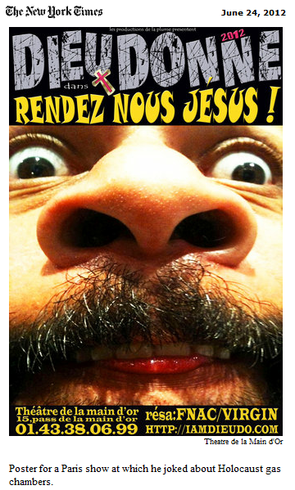¶“Onstage, I used to forget that I was the Jew and he the black guy,” Mr. Semoun said in an interview. “We were profoundly anti-racist. We were the symbol of anti-racism.”
¶After their split Dieudonné went solo. He has written and performed in 13 shows and appeared in more than 20 films, including the 2002 French blockbuster “Astérix and Obélix Meet Cleopatra.” His latest film, “L’Antisémite,” ridicules Auschwitz by showing black-and-white images of an American soldier inspecting a gas chamber and mocking tools, like shower heads, used by the Nazis to kill Jews.
¶The movie was deemed dreadful in an article in Le Nouvel Observateur, and the executive director of the film market in Cannes, Jérôme Paillard, said the screening was canceled because “we ban the presence of any movie which affects public order and religious convictions.”
¶But on a recent Thursday, Dieudonné, charismatic and imposing with big rings and full beard, said he didn’t care. His humor is imbued with a disenchantment of a society that lies and “protects its own interests.”
¶But he remained vague about the reasons for his views. “ ‘Dirty Jew’ is as intolerable as ‘dirty Arab,’ ” Dieudonné told the Swiss newspaper Le Temps in 2004. “But it is more difficult to be black than to be a Jew when you look for a job.”
¶He decries what he calls the “domination of Zionists” in Western societies and the overemphasis on the horrors of the Holocaust to the exclusion of other crimes, like slavery and racism. “Our submission to the Shoah has come to such degree that it became a new religion,” Dieudonné said in the interview. Compared with other suffering, like slavery, “it is not unprecedented on a human scale,” he said.
¶(He’s also not too fond of the United States, using an epithet to describe President Obama as a “servant who does more than he’s asked.”)
¶For some of his fans Dieudonné is just a professional provocateur, disconnected from realities. “He is funny above all,” said Jean-François Saqué, 31, a technician who saw his first Dieudonné show this month. “What worries me is when you start taking seriously what a comedian says.”

